Агентные системы MCP

Google project mariner

Gemini sdk MCP tools

Gemini app agent mode

Alfa go Alfa zero - агентные системы

Project astra

[NVIDIA CEO Jensen Huang Keynote at COMPUTEX 2025](https://www.youtube.com/watch?v=TLzna9__DnI&t=1640s)

1:10:00

NVIDIA NEMO

NVIDIA IQ bluepring

VAST

DELL datastorage platform

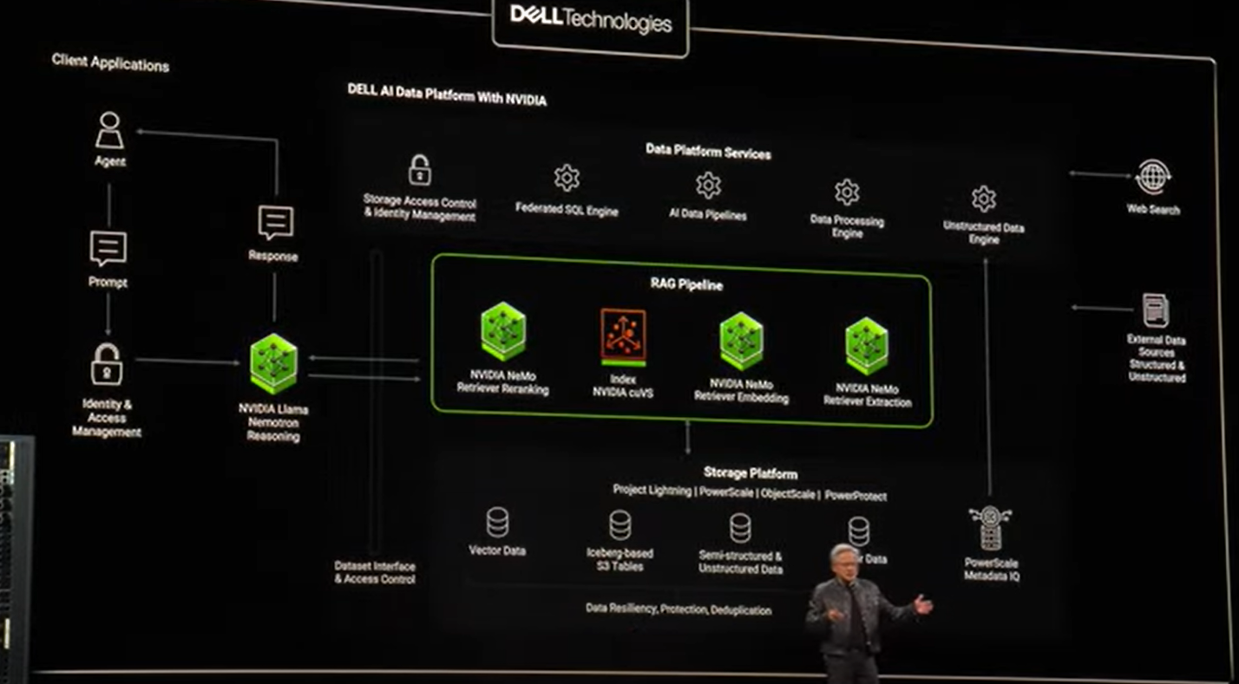

IBM dataplatform